

V 1.2
June 2026
XStep Design Specification
SMPL: Solution Storage/Handling

Table of Contents
1 Purpose 3
2 Overview 3
3 Reasons for developing 4
4 Authorization 4
5 Assumptions/ Dependencies 4
6 Validation Checks 4
7 Configuration Specification 5
8 XStep Layout Design 5
9 Function Module(s) 6
10 Pseudocode 9
11 Test Scenarios 13
12 Revision History 15

Purpose
This document outlines the design, along with the configuration specifications for the XStep “SMPL: Solution Storage/Handling”.

Overview
This SMPL: Solution Storage/Handling XStep defines the requirements for managing a filtered solution, including storage conditions, preparation date, and expiration date. It enables visibility and traceability of both the solution preparation and expiration dates.
The XStep contains three main input parameters:
- IV_HEADER - This can be changed in SiMPL MBR to display specific header text for the XStep
- IV_INSTR - This can be changed in SiMPL MBR to display a specific set of instructions for the XStep that will be displayed below the header
- IV_PO_PREP – This is used in SiMPL MBR to reference the expiry date listed for the Primary Solution of the Top-Off step, if available. More details to configure this will be found in the Parameter Reference document.
- IV_PO_EXP – This is used in SiMPL MBR to reference the preparation date from the first component addition step, if available. More details to configure this will be found in the Parameter Reference document.
- IV_STOR - This can be changed in SiMPL MBR to display the specific Storage Conditions required for the process. By default it is set to “15 – 25 °C” but can be changed to any applicable text.
- IV_SIGN – This can be changed in SiMPL MBR to author standalone signatures as part of the xstep.
The following information is pre-populated:
- “Storage Conditions” - Output
- “Solution Preparation Date” - Input with default retrieved date
The operator retrieves the Preparation Date and Expiration Date using the “Get Solution Expiry” Function button. The function module ZSMPL_FM_UPDATE_SLED_DOM calculates the solution expiration date by adding the material’s shelf life to the Date of Manufacture (preparation date).
- “Solution Shelf Life” - Output
- “Current Solution Expiry” - Output
On completion of the Solution Storage/Handling step, the function ZSMPL_FM_UPDATE_SLED_DOM will be executed again, with the purpose of updating the current material/batch with its new Date of Manufacture and Shelf-Life Expiration Date.

Functional Design
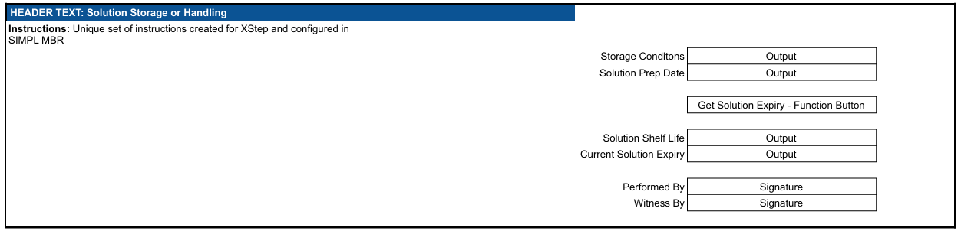

Reasons for developing
The development of the “SMPL: Solution Storage/Handling” XStep is necessary to ensure accurate and consistent tracking of solution preparation and expiration data for filtered solutions within the manufacturing process.

Authorization
Authorization required to update Batch values such as DOM & SLED. (Transaction – MSC2N)

Assumptions/ Dependencies
 | Assumption
1 | Operator signing signature fields is an approved operator in the system with the correct access configuration
2 | The function module can successfully pull the data into the output fields
3 | The logged-on user has the necessary authorizations required to update the batch of a material.

Validation Checks
Error Handling
Error | Action
Operator Signature rejected due to an incorrect username or password | Operator accepts error message and re-enter the correct username and password

Configuration Specification
N/A

XStep Layout Design
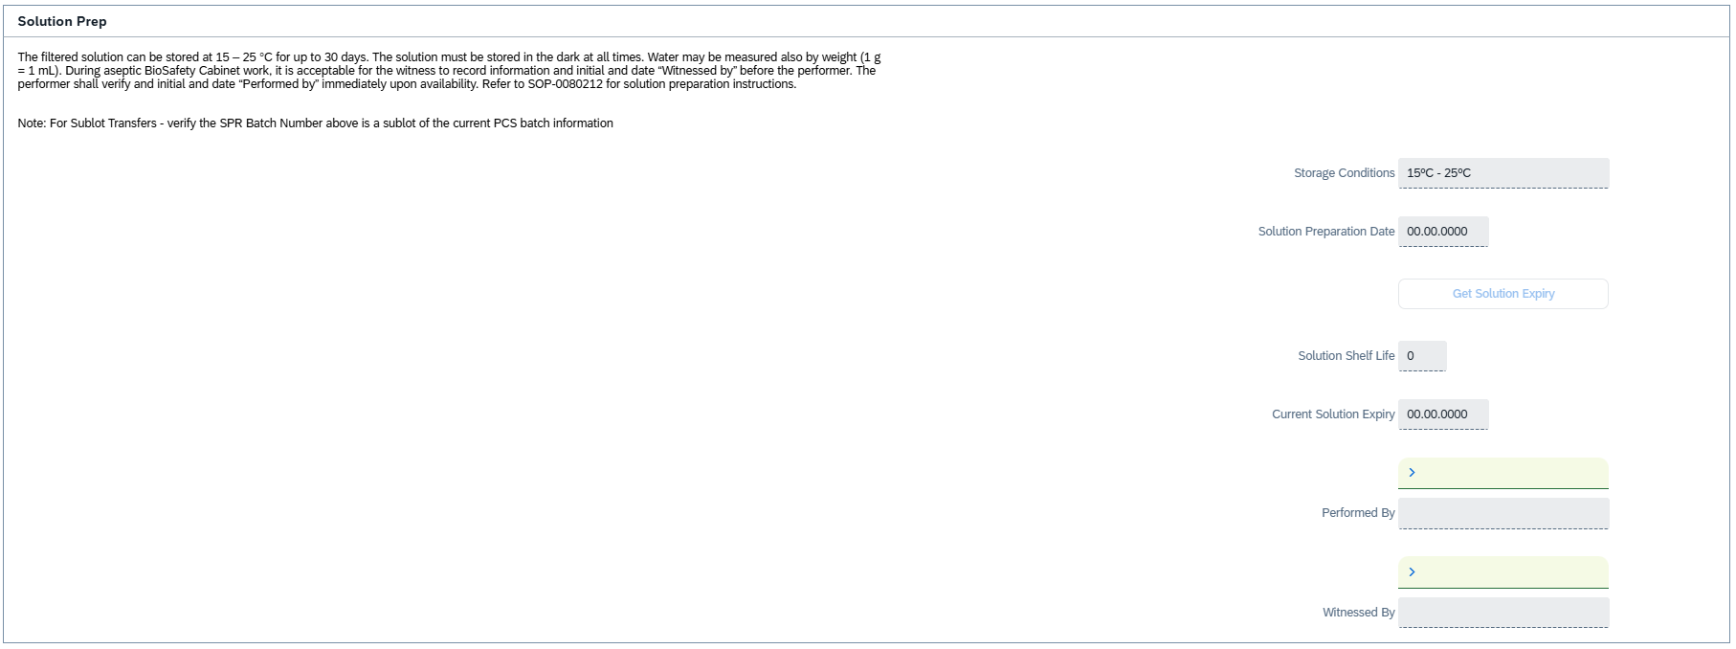

Function Module(s)
Function: GET_SYSTEM_TIME_REMOTE
Export Parameters:
Parameter Name | Associated Type | Short Text
K_DATE | DATS | Kernel date
K_TIME | TIMS | Kernel time
L_DATE | DATS | Local date (ABAP)
L_TIME | TIMS | Local time (ABAP)

Function: /SMPL/PPPI_FM_INITIAL_ACTIVE
Import Parameters:
Parameter Name | Associated Type | Short Text
IV_ACTIVE | CHAR1 | N/A

Export Parameters:
Parameter Name | Associated Type | Short Text
EV_ACTIVE | CHAR1 | N/A

Function: /SMPL/MBR_DEP_CHECK_ACTIVE
Import Parameters:
Parameter Name | Associated Type | Short Text
IM_CONTROL_RECIPE | POC_DOCID | N/A
IM_PHASE | VORNR
IM_AUFNR | AUFNR
IM_STEP_UUID | /SMPL/MBR_SOG_UUID
IM_PLANT | WERKS_D

Export Parameters:
Parameter Name | Associated Type | Short Text
EV_ACTIVE | CHAR1 | N/A

Exceptions:
Exception | Short Text
CONTROL_RECIPE_INITIAL

Function: /SMPL/PPPI_FM_SET_DATE_VALUE
Import Parameters:
Parameter Name | Associated Type | Short Text
IV_DATE | DATS | Input date
Export Parameters:
Parameter Name | Associated Type | Short Text
EV_DATE | DATS | Output date

Function: ZSMPL_FM_UPDATE_SLED_DOM
Import Parameters:
Parameter Name | Associated Type | Short Text
IV_MATNR | MATNR | Material Number (optional)
IV_CHARG | CHARG_D | Batch (optional)
IV_WERKS | WERKS_D | Plant (optional)
IV_DOM | DATS | Date of Manufacture / Preparation Date (optional)
IV_SLED_FLAG | CHAR1 | SLED flag (optional)
IV_SLED | DATS | Shelf-Life Expiration Date (optional)
IV_UPDATE_FLAG | CHAR1 | Update batch flag (optional)
Export Parameters:
Parameter Name | Associated Type | Short Text
EV_EXPIRY | DATS | Calculated solution expiry (SLED)
EV_SHELF_LIFE | INT3 | Shelf life (days)
Exceptions:
Exception | Short Text
NO_SHELF_LIFE | No shelf life maintained for the material
UPDATE_FAILED | Batch DOM/SLED update failed

Pseudocode
Function: GET_SYSTEM_TIME_REMOTE
1. Initialization
a. No explicit parameter initialization or clearing is required, as all parameters are export-only.
b. Developer comment clarifies the time returned is based on the calling user's time zone, not the application server.
2. Retrieval of Local System Time
a. The local date (L_DATE) and local time (L_TIME) are derived directly from system fields:
- L_DATE = SY-DATUM → System date (UTC or system time zone depending on configuration)
- L_TIME = SY-UZEIT → System time
Note: Although a comment suggests SY-DATLO and SY-TIMLO (local time of the user) might be used, the code intentionally uses SY-DATUM and SY-UZEIT instead.
3. Retrieval of Kernel Time
a. The function SQLT_TRACE_KERNEL_TIME is called to retrieve the kernel-level timestamp, which typically reflects the UTC-based time from the system kernel, independent of the ABAP stack.
b. The exporting parameters K_DATE and K_TIME are populated from this call, providing a reliable baseline for time comparisons across distributed systems (e.g., in RFC or ALE scenarios).
4. No Selection Logic
- There is no conditional logic, user interaction, or fallback handling required.
- The function executes deterministically and returns four time values.
5. Output Assignment
a. The following four export parameters are returned:
- K_DATE – Kernel (UTC/system) date
- K_TIME – Kernel (UTC/system) time
- L_DATE – Local date (from system field SY-DATUM)
- L_TIME – Local time (from system field SY-UZEIT)
Additional Notes
- Purpose:
To return both the system kernel time and the ABAP runtime local system time, which can be used for time synchronization or timestamp logging across systems (especially useful in RFC scenarios where time zones may differ between client and server).
- Key Features:
  - Differentiates between kernel-level and ABAP-level time values
  - Simple and lightweight function for remote consumption
  - Can help detect latency, skew, or drift in distributed environments
- Error Handling:
  - No TRY...CATCH block is used, as the SQLT_TRACE_KERNEL_TIME is considered stable
  - No exceptions are raised explicitly
- Assumptions:
  - The system has access to the standard SAP kernel function SQLT_TRACE_KERNEL_TIME
  - No user-specific time zone logic is required, as this function assumes ABAP context only
Function: /SMPL/PPPI_FM_INITIAL_ACTIVE
1. Initialization
a. Input parameter IV_ACTIVE is optionally provided by the calling logic.
b. Constants gc_yes, gc_no, and gc_inside_range are assumed to be defined globally in the context of the function module.
2. Active Flag Evaluation
a. The function checks if the input value IV_ACTIVE falls within the expected valid range, represented by gc_inside_range.
b. Based on the result:
- If the input value is not equal to gc_inside_range, the XStep is marked as inactive by setting EV_ACTIVE = gc_no.
- If the input value is equal to gc_inside_range, the XStep is marked as active by setting EV_ACTIVE = gc_yes.
3. Output Assignment
a. The evaluated result is returned in the EV_ACTIVE export parameter for use by the calling logic (e.g., XStep configuration, PI sheet rendering).
Additional Notes
- This is a simple normalization function that abstracts how activation flags are interpreted for PPPI XSteps
- The use of constants (gc_yes, gc_no, and gc_inside_range) allows the logic to be aligned with broader application settings or standards.
- Helpful in scenarios where input values may vary but need to result in consistent "active" or "inactive" behavior.
- Input is optional, so defaulting behavior can be configured outside this function.
- This function improves clarity and consistency in determining whether an XStep should be active when rendered in the PI Sheet.

Function: /SMPL/MBR_DEP_CHECK_ACTIVE
1. Initialization
a. Input parameters provide context for determining whether an MBR (Manufacturing Batch Record) step can be activated:
- IM_CONTROL_RECIPE (POC_DOCID) – Control recipe ID identifying the batch instruction.
- IM_PHASE (VORNR) (Optional) – Operation or phase within the process order.
- IM_AUFNR (AUFNR) (Optional) – Process order number associated with the step.
- IM_STEP_UUID (/SMPL/MBR_SOG_UUID) – Unique step identifier (SOG).
- IM_PLANT (WERKS_D) – Plant code for process context.
b. The function first validates that IM_CONTROL_RECIPE is not initial.
- If it is initial, the exception CONTROL_RECIPE_INITIAL is raised.
c. Internal data is initialized:
- lt_ord_sigs: Internal table for storing order signature data from /SMPL/MBR_OR_SIG.
- ls_step_dep: Work area for step dependency data.
- Routine LOAD_INTERNAL_DATA is called to populate internal buffers (g_ord_data-t_ord_deps) using IM_AUFNR, IM_CONTROL_RECIPE, and IM_STEP_UUID.
2. Signature Data Retrieval
a. The function retrieves signature records for the process order from database table /SMPL/MBR_OR_SIG.
b. Selected fields include: AUFNR, SOG_UUID, TYPE, CREATED_DATE, CREATED_TIME, DEST_NAME, SIGN_ID, SIGN_DATE, and SIGN_TIME.
c. Only signatures related to the specified order (AUFNR = IM_AUFNR) are selected.
d. These records are stored in the internal table lt_ord_sigs for later evaluation.
3. Dependency Evaluation
a. The function loops through dependencies in g_ord_data-t_ord_deps where:
- TARGET_UUID = IM_STEP_UUID, and
- DEP_RULE is either gc_perform_before_start_rule or gc_verify_before_start_rule.
b. For each dependency record:
- If the rule is PERFORM BEFORE START, it checks whether the prerequisite step (PREREQ_UUID) has a pending perform signature (gc_perform_signature) with SIGN_ID = abap_false.
- If the rule is VERIFY BEFORE START, it checks whether the prerequisite step (PREREQ_UUID) has a pending verify signature (gc_verify_signature) with SIGN_ID = abap_false.
c. If an incomplete signature is found, the step is marked inactive (EV_ACTIVE = gc_step_inactive).
d. If all prerequisite signatures are complete, the step is marked active (EV_ACTIVE = gc_step_active).
4. Output Assignment
a. The evaluated activation status is returned in the export parameter EV_ACTIVE.
- gc_step_active – All prerequisite steps are completed; the current step can start.
- gc_step_inactive – At least one prerequisite step is incomplete; the current step remains blocked.
Additional Notes
This function determines whether a dependent step in a Manufacturing Batch Record is eligible to start based on the completion of prerequisite steps.
Key Features:
- Evaluates Perform Before Start and Verify Before Start dependency rules.
- Dynamically validates signature data from /SMPL/MBR_OR_SIG.
- Integrates with existing MBR dependency structures via global table g_ord_data-t_ord_deps.
Error Handling:
- Raises CONTROL_RECIPE_INITIAL if the control recipe input is missing.
- Handles empty dependency or signature data without runtime errors.
Dependencies:
- Tables: /SMPL/MBR_OR_SIG (Signatures), g_ord_data-t_ord_deps (Step Dependencies).
- Constants: gc_perform_before_start_rule, gc_verify_before_start_rule, gc_perform_signature, gc_verify_signature, gc_step_active, gc_step_inactive.
- Routine: LOAD_INTERNAL_DATA for initializing order context.
Assumptions:
- All prerequisite steps are recorded in the dependency table.
- Signature records are current and synchronized with MBR step progression.
Activation status is recalculated each time the function is called to reflect live signature data.

Function: /SMPL/PPPI_FM_SET_DATE_VALUE
1. Set / Normalise Date
a. Take the input date IV_DATE and return it in EV_DATE.
Additional Notes
Simple date set/normalisation utility; used to populate the Solution Preparation Date and Current Solution Expiry date fields. No exceptions are raised.
Function: ZSMPL_FM_UPDATE_SLED_DOM
1. Purpose
Calculates the solution expiry (SLED) by adding the material's shelf life to the Date of Manufacture / preparation date (DOM), and optionally updates the batch master with the new DOM and SLED. Backs the 'Get Solution Expiry' button and the end-of-step batch update.
2. Inputs
a. IV_MATNR / IV_CHARG / IV_WERKS identify the material, batch and plant; IV_DOM is the date of manufacture (preparation date); IV_SLED, IV_SLED_FLAG and IV_UPDATE_FLAG control the calculation and update behaviour.
3. Calculate Expiry
a. Read the material's shelf life; if none is maintained, raise NO_SHELF_LIFE.
b. Compute EV_EXPIRY = DOM + shelf life and return the shelf life in EV_SHELF_LIFE.
4. Update Batch (optional)
a. If IV_UPDATE_FLAG is set, update the batch master DOM and SLED with the calculated values (as in MSC2N); raise UPDATE_FAILED if the update cannot be performed.
Additional Notes
Returns EV_EXPIRY and EV_SHELF_LIFE; updates the batch DOM/SLED when requested. Exceptions: NO_SHELF_LIFE, UPDATE_FAILED.

Test Scenarios
# | Scenario | Expected Result | Actual Result | Pass/ Fail
1 | Create and Release a Process Order with the pre-configured SiMPL Master Recipe and the relevant Production Version | Process Order created and Released containing SMPL: Solution Prep Var | Process Order created and Released containing SMPL: Solution Prep Var
2 | Open the EBR, and navigate to SMPL SMPL: Solution Prep Var | The EBR for the selected Process Order and Control Recipe opens successfully without any errors and the SMPL: Solution Prep Var is visible | The EBR for the selected Process Order and Control Recipe opens successfully without any errors and the SMPL: Solution Prep Var is visible
3 | The value entered in parameter IV_HEADER and parameter IV_INSTR in SiMPL MBR appears correctly in the XStep header | Header and instruction text are displayed as authored in SiMPL MBR | Header and instruction text are displayed correctly.
4 | Operator retrieves Shelf Life and Expiration Date using the pre-populated Preparation Date using the “Get Solution Expiry” button. | Preparation Date is pre-populated and Expiration Date and Shelf Life values are retrieved and correct. | Preparation Date is pre-populated and Expiration Date and Shelf Life values are retrieved and correct.
5 | Enter a username in the “Performed By” field then enter the password in the pop-up window. | Signature is accepted | Signature is accepted
6 | Enter a username in the “Witnessed By” field then enter the password in the pop-up window. | Signature is accepted and the xstep locks. | Signature is accepted and the xstep locks.
7 | Navigate to MSC2N for current material/batch to ensure DOM & SLED are correctly update. | SLED & DOM fields in batch master match to Prep Date and Expiry Date fields in the step. | SLED & DOM fields in batch master match to Prep Date and Expiry Date fields in the step.

Revision History
Version No. | Description | Author | Date
1.1 | Initial document (Functional Requirements and Technical Specifications) | Karla Uys and Frieda van der Merwe | 18-06-2025
1.2 | The following Technical Spec sections added to spec: Function Module(s), and Pseudocode. | Juna Jaouhari | 22-06-2026
1.3 | Updated to align the specification with the current XStep version (v0005). Added Function Module and Pseudocode sections for the two undocumented main-step modules: /SMPL/PPPI_FM_SET_DATE_VALUE (sets the Solution Preparation/Expiry date fields) and ZSMPL_FM_UPDATE_SLED_DOM (Get Solution Expiry - calculates SLED from DOM + shelf life and updates the batch DOM/SLED). Removed ZSMPL_FM_GET_ASSIGNED_EQUI_EBR, which is not called by this XStep. Corrected the GET_SYSTEM_TIME_REMOTE L_DATE/L_TIME export labels. (Function modules used only by the embedded Conditional Header / Optional Signature references are not documented here.) | [Author] | 23-06-2026

